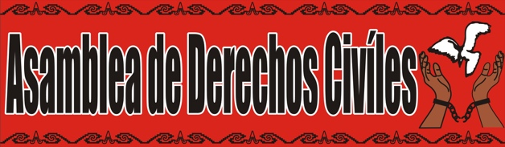

9/29/17

Dear MPHA Board of Commissioners,

Asamblea de Derechos Civiles (Assembly for Civil Rights) is a faith-based non-profit organization that has worked extensively in affordable housing preservation, tenants’ rights, and preventing displacement of immigrant and low-wealth communities. We write in support of the demands made by Defend Glendale and the Public Housing Coalition.

Recent attacks at the federal level hit close to home for Glendale residents- from proposed further gutting of HUD funds, the threat of diminished fair housing enforcement, the refugee ban, and the suggested creation of a Muslim registry. To be clear, these attacks are not only an attack on “affordable housing units” and “funding,” they are an attack on human beings who live and belong in this community, and many of whom live in public housing. This current moment in history and the decisions you make will be seen through the lens of this reality.

While MPHA does not directly control the political rhetoric and decisions coming from Washington DC, it does have to choose how to position itself in response to them. The legacy and daily reality of institutional and structural racism demand that MPHA begin to see itself and the way it makes decisions differently, and share decision making power with the communities that have organized to stand up for family, home and community.

In our experience, public agencies rarely acknowledge the risk of displacement or take responsibility for their actions leading to displacement until it is “too late.” Therefore, simply denying the merits of Defend Glendale and the Public Housing Coalition’s concerns is insufficient. Instead the demands of justice call upon MPHA to come to agreement with residents on their long-stated desire for repair and rehabilitation of their homes without demolition and displacement.

We honor Defend Glendale and the Public Housing Coalition for the commitment of their leadership, their persistence in this struggle, and the power of their vision for a more equitable housing system. We urge you to support their efforts as well.

