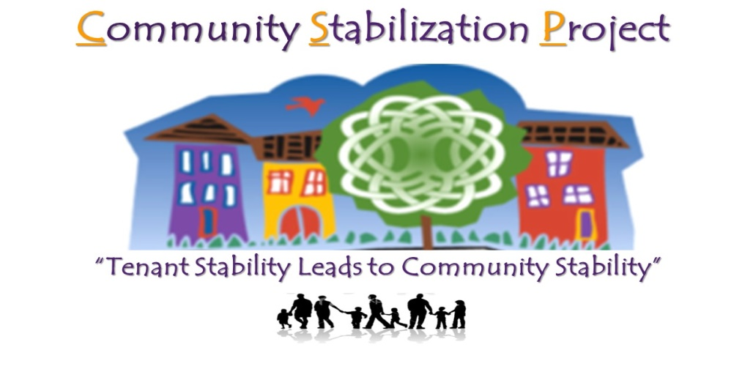
The Community Stabilization Project endorses the Defend Glendale Campaign and their vision and goals to remain a stable, vibrant, and empowered, affordable housing community of 184 families and 600 people, of 50% children, in addition to achieve their main mission for the Minneapolis Public Housing Authority (MPHA) to provide 100% long neglected home repairs and 0% displacement of their current residents.
We support Defend Glendale leaders to pressure MPHA to end their neglect and ignoring of Glendale Townhomes’ residents voices regarding planning, decisions, and conversations regarding demolition and redevelopment of their homes.
Our organization joins with Defend Glendale leaders and their diverse coalition of allies to create and preserve affordable publically owned housing development in Minneapolis and throughout the region. We support Defend Glendale to continue to meet with City officials, U.S Department of Housing & Urban Development ( HUD), allies, MPHA, the local neighborhood association, and various organizations to protect and preserve Glendale Townhomes.
We stand with Defend Glendale’s right to organize against racial inequity, housing injustices, gentrification, and displacement. Defend Glendale has the right to stay in their homes, protect their families and children’ s future to have safe and healthy affordable housing near transit options for low-income and working class families..
We support Defend Glendale’s demands of MPHA becoming fully accountable to the City of Minneapolis Housing Division, a staff leadership change in MPHA, and a signed City of Minneapolis enforceable deliverables agreement between MPHA and Defend Glendale for 100% repairs of Glendale Townhomes and 0% displacement completed by Dec 31, 2017.
Signed,

